React by thapa technical

React is js library for building user interfaces

Benefits –

1)components base approach

2)uses declarative approach

3)dom updates are handled gracefully in react

4)reusable code

5)react is designed for speed, speed of implementing the application simplicity and scalability

5)

Webpack – jo bhi files hai uska ek bundle bana kar rakhata hai

Babel – js complier, jo modern js ko old(browser samjata )js me convert karta hai

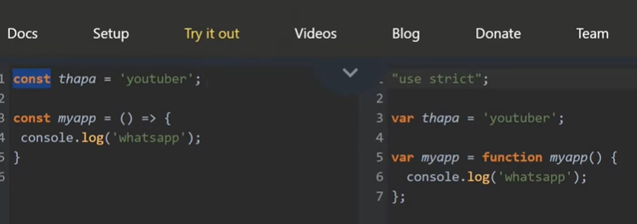

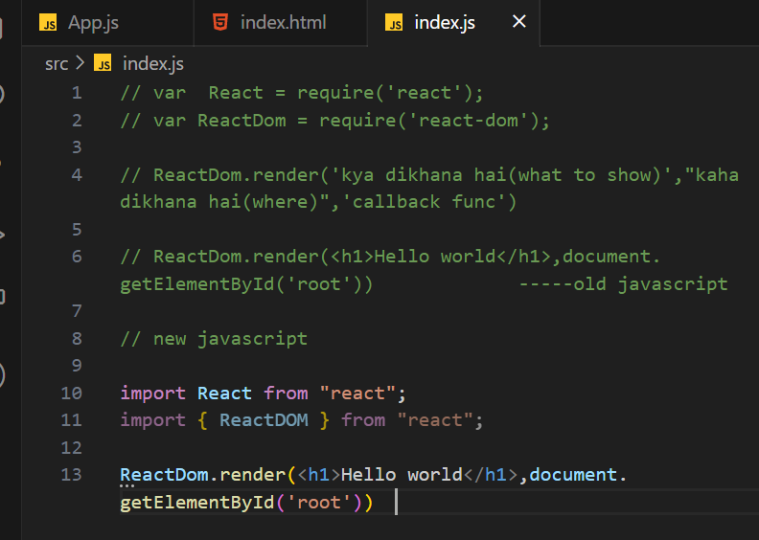

6)jsx – javascript xml

7) 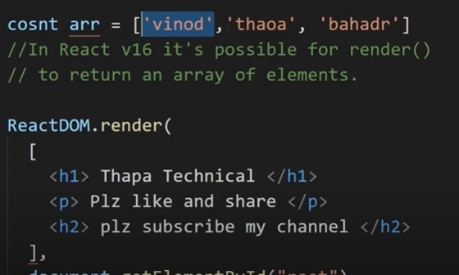 to add multiple elemets in render 1)make array 2)react fragment 3)div

8)react fragment –

Jab hum multiple elements bind karne ke liye div use karte hai, to vo id=root div ke andar ek aur div create karta hai

Benefits –1)thoda bohot faster 2)less memory consuming 3) reduce complexity while css

10)jsx expression in react -- for dynamic variable we use {}

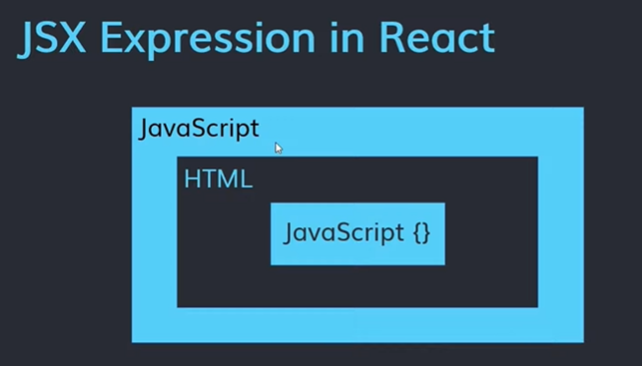

11)template literals - -

 ---backticks

12)

13)jsx attributes - -same as html attributes

14)css – inline css 

15)google font-

16) 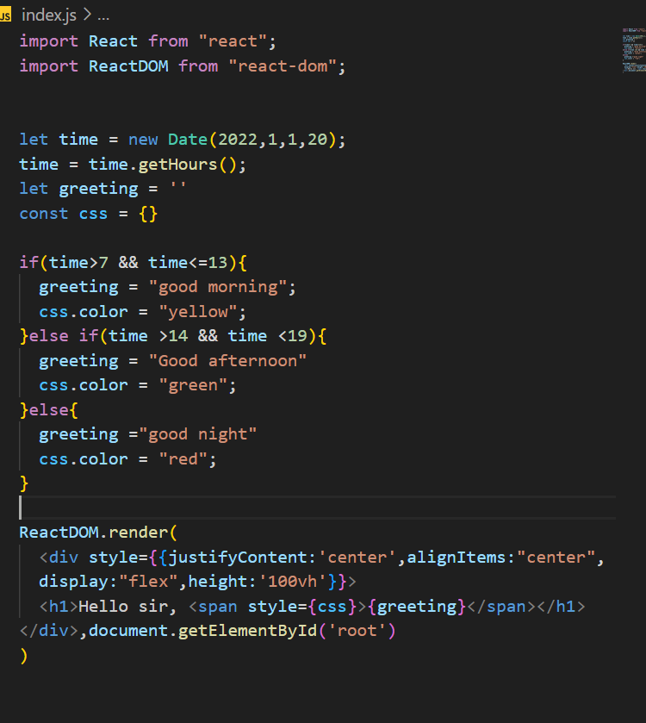

18)Componentes –

19)challenge –

20)import export – 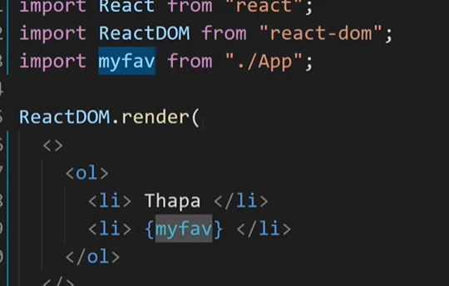we can change name of import when its default.

Je export default nasel tyala {import} karav laagel. 

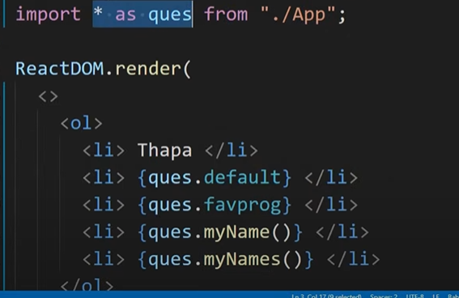 sagle sobat import karnyasathi

21)challenge –

22) props in react –props ==properties

23)arrays – store data in arrays

24)array.map() –



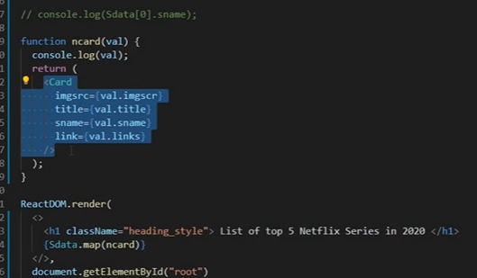

Fat arrow function – (=>)

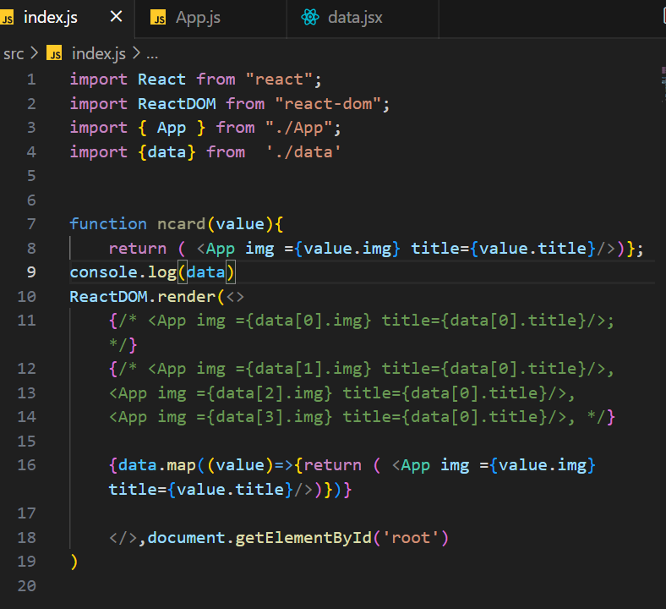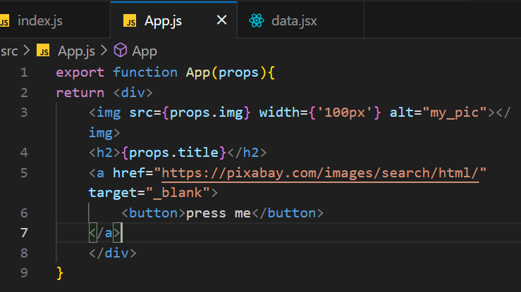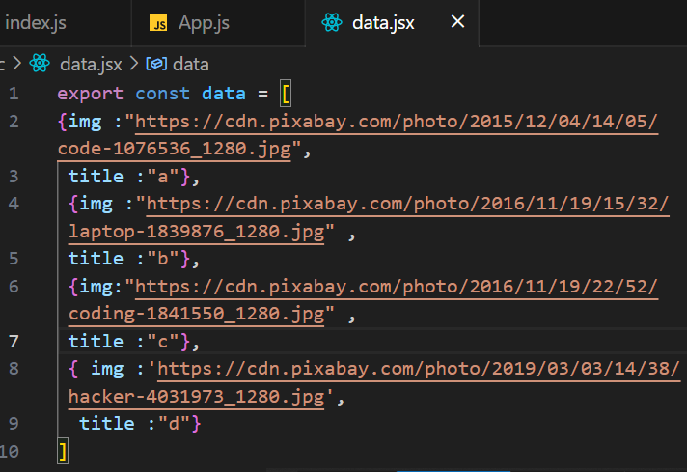

25)

26)conditional rendering - -

27)ternary operator - -



28) slot machine challenge –

Object DE structuring --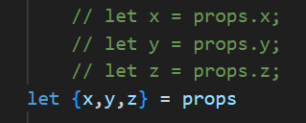

30)Hooks-

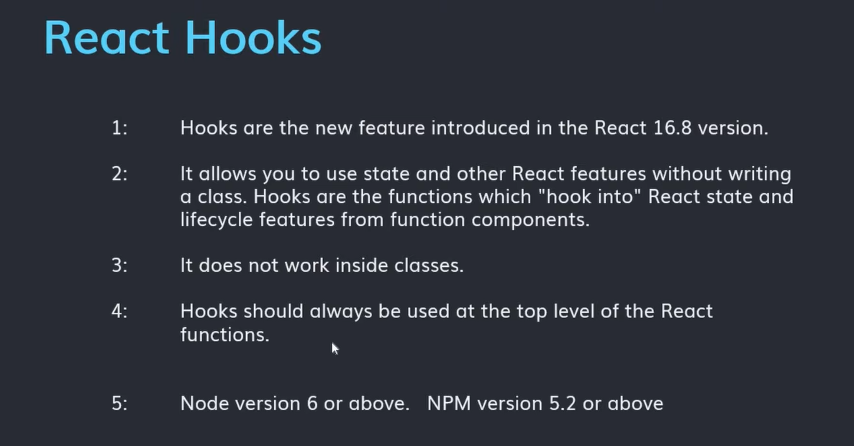

React uses camelCase.

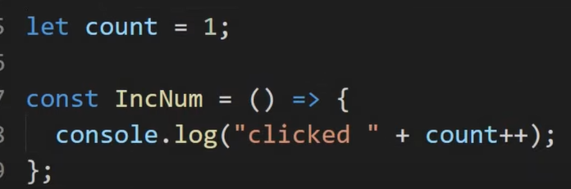 -count++ not works with 1, it works in console.

Problem with functional compo –

We can’t change the value of 1 using button Ie we can’t change its state, it is same, that’s why developers shift to class components but it is also lengthy

Now replace with hooks

1)usestate hook – state change karnyasathi

State – color,width,face value,static - dynamic

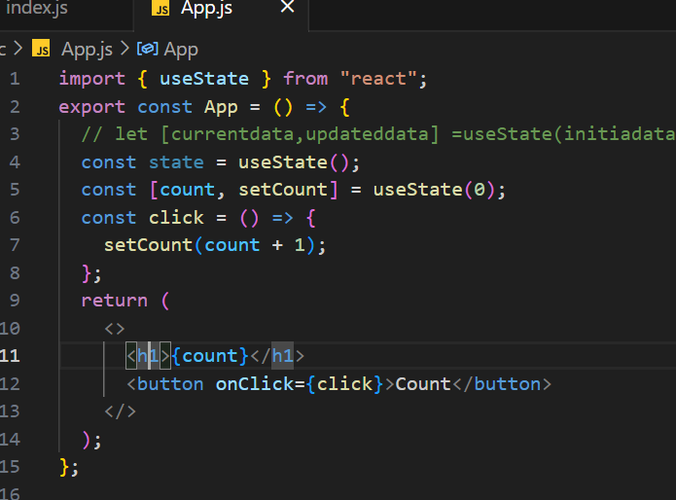

33) handling event - -

34)forms –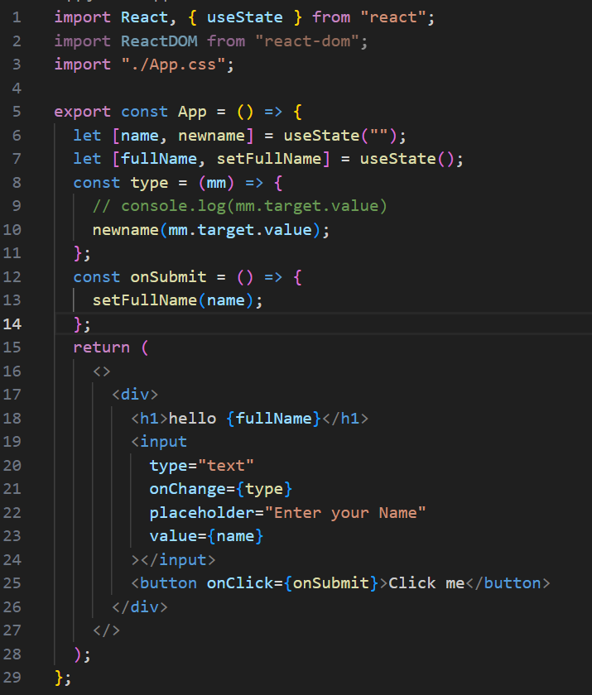

Controlled component –



36) handling complex multiple input form -

38)spread operator – array copy karnyasathi

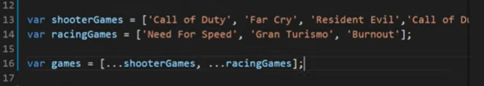

39)

40)material UI –

Competitor of fontawesome

Fontawesome –

Install -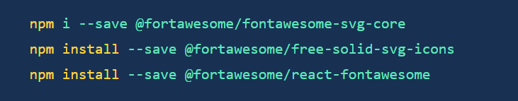

Import –



Use-

It is an react library which is use to simplify coding, giving direct code access to component like button,icons,checkbox and many more

Steps to use-

1 ) install 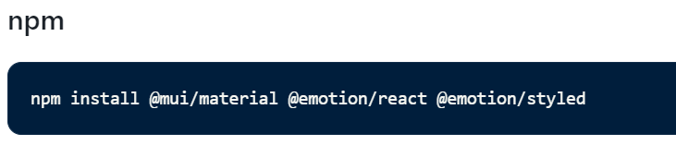

2)import what you want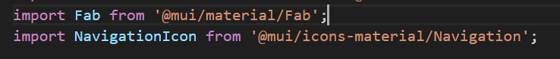

44)node package manager –(npm) - -

45)bootstrap:

Bootstrap is a free and open-source front-end framework for developing websites and web applications. It is based on HTML, CSS, and JavaScript. Bootstrap includes a number of features that make it a valuable tool for web developers, including:

* A grid system for creating responsive layouts
* A library of pre-built components, such as buttons, forms, and navigation bars
* A set of JavaScript plugins for adding functionality to websites, such as modals and tooltips

We can add css using classname in bootstrap, no need to create separate css file